4357. Embedded Firmware Essentials

Homework #3

Jae Yang Park ([jaeyangp@gmail.com](mailto:jaeyangp@gmail.com))

**Source**

//

// example 7.9

// Async communication

#include "mbed.h"

**Serial async_port(p9, p10);**

DigitalOut red_led(p25);

DigitalOut green_led(p26);

DigitalOut strobe(p7);

DigitalIn switch_ip1(p5);

DigitalIn switch_ip2(p6);

char switch_word;

char recd_val;

int main()

{

**async_port.baud(9600);**

while (1) {

switch_word = 0xa0;

if (switch_ip1 == 1)

switch_word |= 0x01;

if (switch_ip2 == 1)

switch_word |= 0x02;

strobe = 1;

wait_us(10);

strobe = 0;

**async_port.putc(switch_word);**

**if (async_port.readable() == 1)**

**recd_val = async_port.getc();**

//

red_led = 0;

green_led = 0;

recd_val &= 0x03;

if (recd_val == 1)

red_led = 1;

if (recd_val == 2)

green_led = 1;

if (recd_val == 3) {

red_led = 1;

green_led = 1;

}

}

}

**Pictures working with program for bidirectional data transfer between two mbed UARTs**

|  |  |
| --- | --- |
| mbed1 (SW1, SW2) | mbed2 (SW7, SW8) |
| C:\Users\Jaeyang\AppData\Local\Temp\x10sctmp3.png  **mbed2**  **mbed1**m | C:\Users\Jaeyang\AppData\Local\Temp\x10sctmp1.png |
| C:\Users\Jaeyang\AppData\Local\Temp\x10sctmp2.png | C:\Users\Jaeyang\AppData\Local\Temp\x10sctmp0.png |
| C:\Users\Jaeyang\AppData\Local\Temp\x10sctmp4.png | C:\Users\Jaeyang\AppData\Local\Temp\x10sctmp.png |

**mbed – Serial class**

Serial(PinName tx, PinName rx, const char *name = NULL)

void attach(T* tptr, void(T::*)(void) mptr, IrqType type = RxIrq)

void baud(int naudrate)

void format(int bits = 9, Parity parity = SerialBase::None, int stop_bits = 1)

int readable()

void send_break()

void set_flow_control(Flow type, PinName flow1 = NC, PinName flow2 = NC)

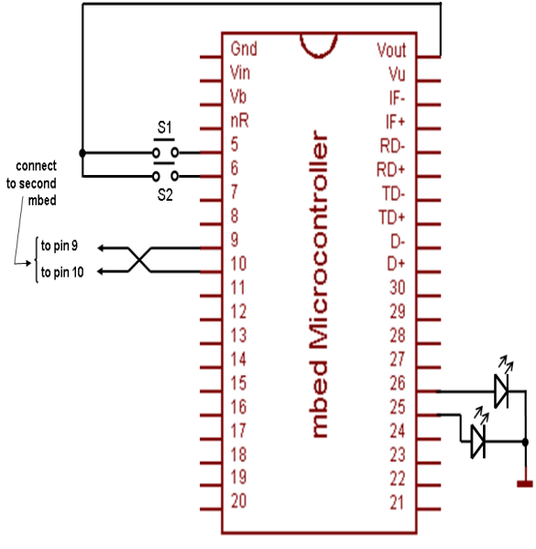

S7

S8

**Total spent hours: 4.5 hours**

* mbed hardware setting and testing (SPI, I2C, UART): 1.5
* mbed library review: 2
* Report: 1